

Prepared by:

**Gerber Technology**

**YuniquePLM**

**Color Folder**

The Color Folder

The *Color Folder* in YuniquePLMTM is where color palettes are created to use in conjunction with materials, artwork, styles, etc. YuniquePLM™ provides the ability to create different palette types, for example seasonal palettes, fabric texture palette, trim palette, etc. These palettes can be seasonal, departmental, brand specific, etc. User permission within the Color Folder can be set according to these palette types.

Creating A New Color Palette

Creating a color palette is the process of creating or choosing colors, grouping them together, and giving that group a name. Colors might be grouped together by brand label, material type, design initiative, etc.

To begin select the Color Folder Icon.

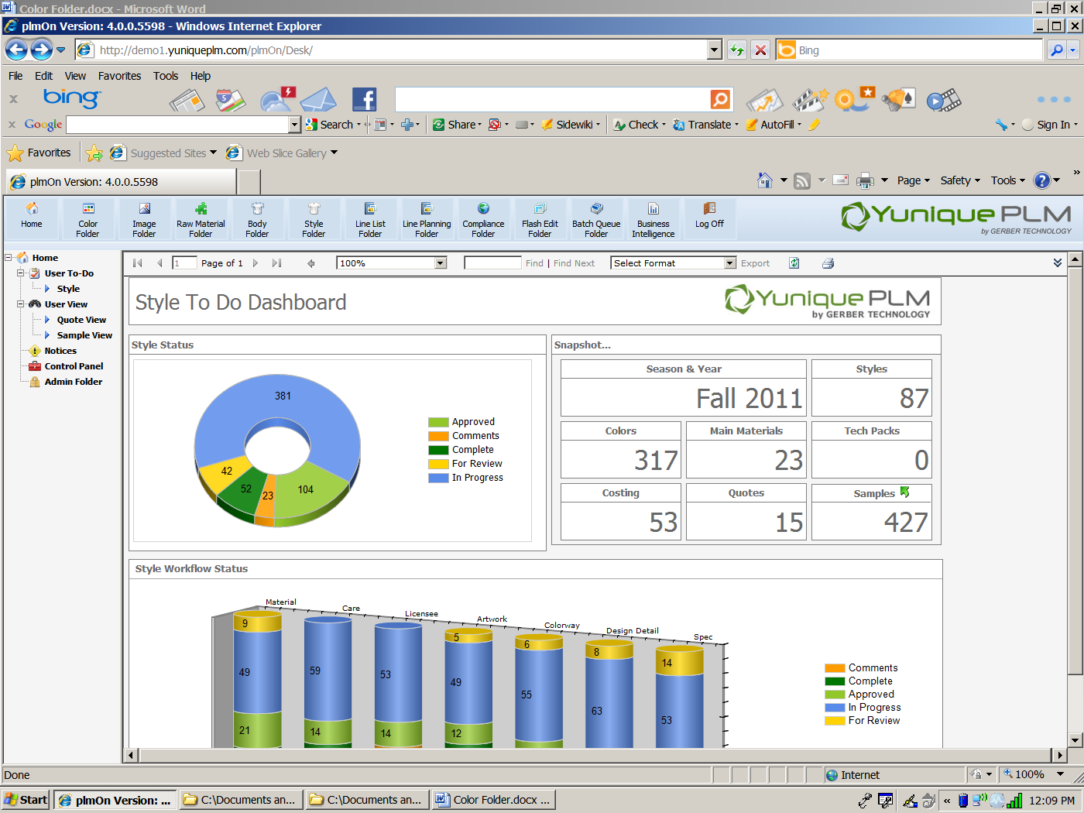

When the color folder opens select the New Palette on the left navigation divider bar or click on the New button on the right hand side of the divider bar across the top.

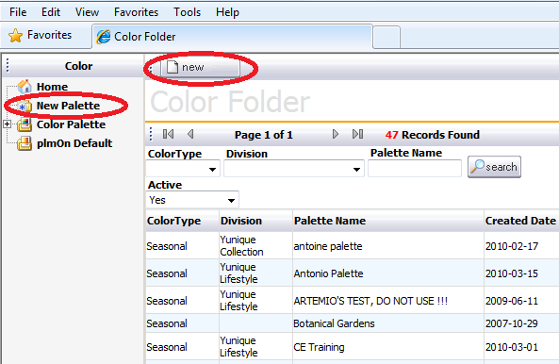

Fill in each of the data fields with appropriate information related to the new color palette and then select the Save button at the top.

**Note**: The data entry fields are configurable and therefore may be different than those shown in this document.

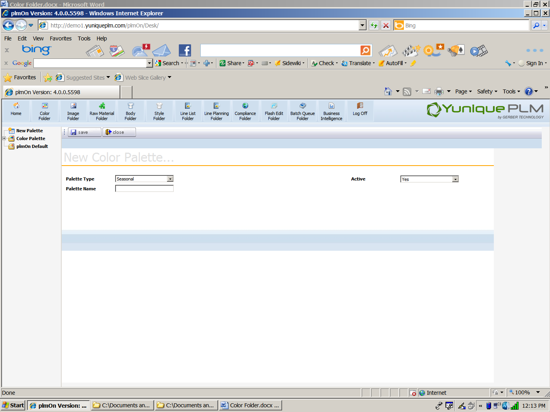

**Adding Colors**

Once the color palette is created colors can be added to the palette. To add colors click on the Add button across the top of the new color palette window.



This will open up the color library window so that colors can be selected. Pantone TCX (for use with cotton materials) and Pantone TPX (for use with paper materials) are available as default color libraries. In addition company specific colors can be configured to display in the default library and/or other color sources can be integrated to YuniquePLM (such as Scotdic™) for a fee.

Individual colors can be selected by choosing a color in the Saturation area in the lower left. This will then display a more specific color selection on the right side of the color library window. Colors within the Pantone or default libraries can also be filtered by entering data in the fields across the top of the color window and then clicking the Search button.

To select specific colors to add to the new palette add a check mark in the upper left corner of the desired color chip(s) and the click on the Add button at the top.

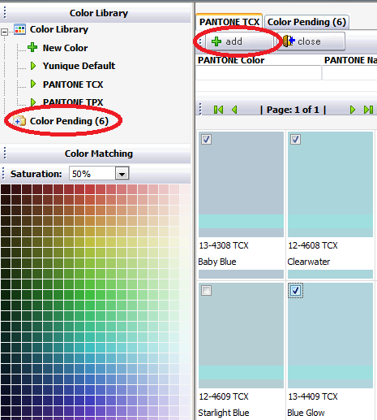

Newly added colors are placed into a Color Pending folder. This allows the user to then review the colors and verify the ones that will officially be added to the color palette, thus preventing accidental entries or entries of colors that are too similar in appearance.

Color Pending can be accessed by selecting the file name on the left side of the window or clicking on the Color Pending tab header at the top.

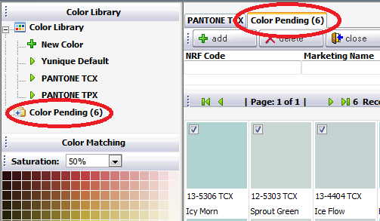

Clicking the Add button at the top of the Color Pending tab will deposit confirmed colors into the color palette.

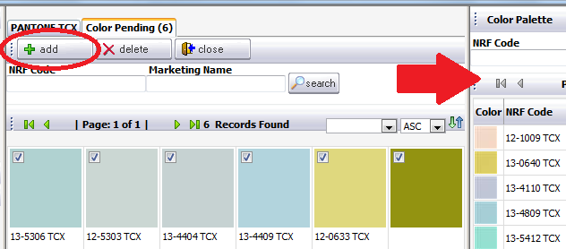

Colors that are not a part of an existing color library can also be added by selecting New Color on the left navigation. The New Custom Color Chip area will be displayed, and colors can be selected by clicking in the various color areas in the RGB display or by uploading an image of a color.

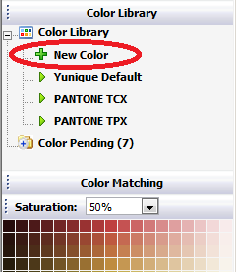

The corresponding RGB and code numbers will be displayed to the right. Data can also be entered in these fields for faster selection. When the color has been created click the Add Color button across the top of the window and it will then be added to the Color Pending area.

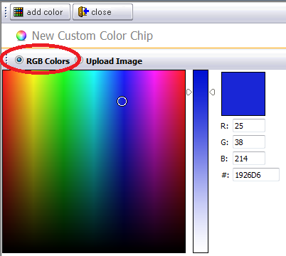

The Upload Image will allow users to browse network locations to find images that have either been generated in a CAD system or scanned.

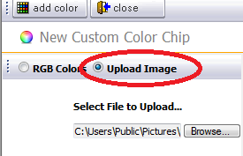

The NRF, Marketing Name and Color Family fields will be entered manually for the new color chip.

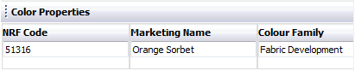

**Note**: These data entry fields are configurable and therefore may be different than those shown in this document

Colors can also be added by copying from previously created color palettes. To do this, click on the Copy button across the top of the color palette window.



This will display the search listing of all other color palettes within the system. Select the color palette in which the desired color(s) to be copied are listed. When the palette is displayed place a check in the upper left corner of the color chips to be copied. Click the Save button across the top. The copied colors will then be added to the Color List of the new palette on the right.

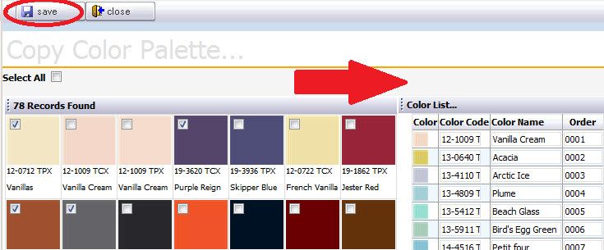

**Season & Year**

The Season & Year attribute is available so that a color palette can be created once for color chips to continually be allocated to the appropriate season/year(s). Once a color palette has been created, the attribute of “Season and Year” can be applied to the palette in order to narrow the list down even further. Within a specific season only certain colors from the original palette would be available.

To select a season and year click on the Season & Year node on the left side of the divider bar and then click on the Add button cross the top right of the divider bar.

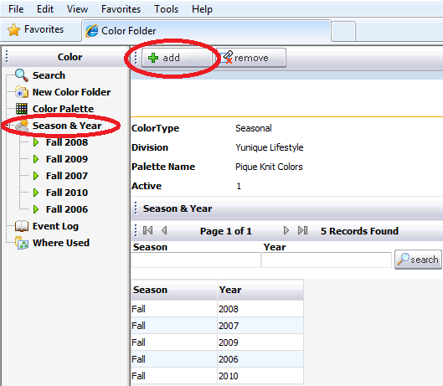

A list of available seasons will be displayed. Place a check in the box to the left of any season/year combinations that should be applied to the color palette then click the Add button across the top of the window.

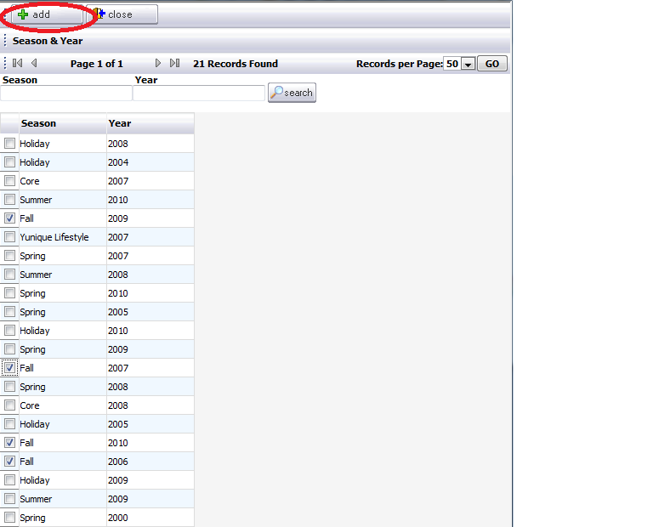

If the list of season/year combinations is very large then a search can be done to more easily select specific seasons and/or years from the list. Simply type the data in the appropriate field and the click the Search button to the right.

Once the season/year combinations have been added, the list of available colors can be narrowed down by selecting from the original color palette. To do this, click on a season/year combination on the left of the divider bar and then click the add button that displays across the top right of the divider bar. All of the colors originally chosen for the color palette will be available. Select specific colors by placing a check mark to the left of the each color and then clicking the Add button across the top.

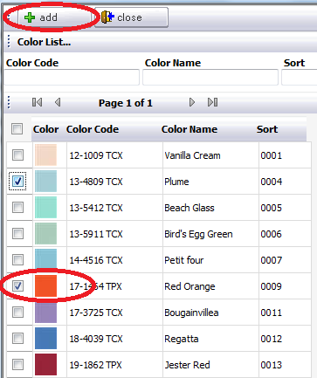

Colors can also be allocated to specific season/year combination(s) at the same time they are being selected for a color palette, on the Color Pending tab. A check mark can be placed to the left of the season/year combination(s) and when the Add button is selected, the color chips will be added to a palette with the season/year attribute.

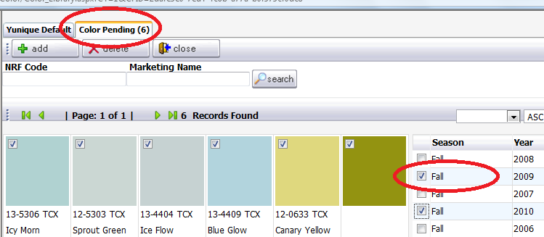

**Editing a Color**

Once colors have been added to a palette, changes can be made to the actual color or to the data associated with the color. This can be done by clicking on the Edit button located directly above each color chip displayed.

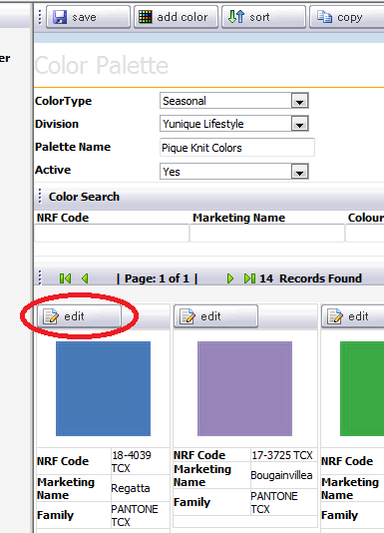

Once the specific color information is displayed changes can be made to the data fields labeled NRF, Marketing Name, and Color Family. This will not affect the original color entry in the master color library. Additionally there are tabs with specific information listed to the far right of the color chip window.

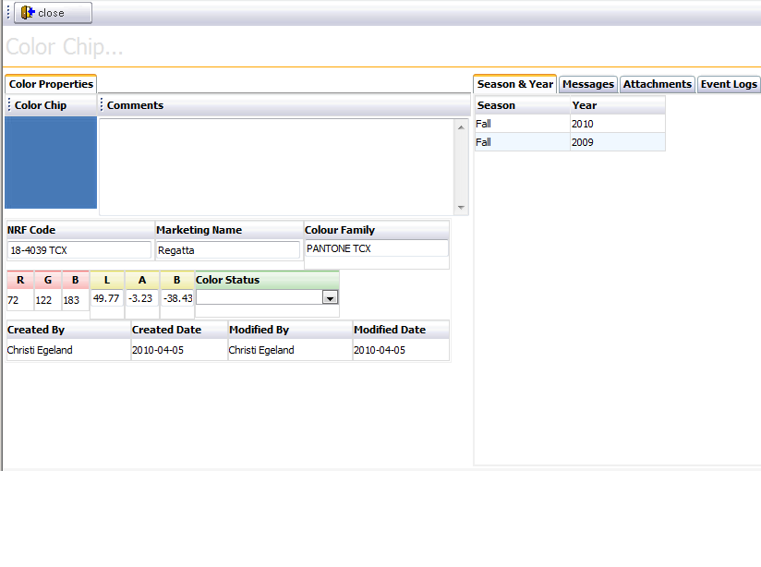

The Season & Year tab will display the season/year combination to which the selected color chip belongs.

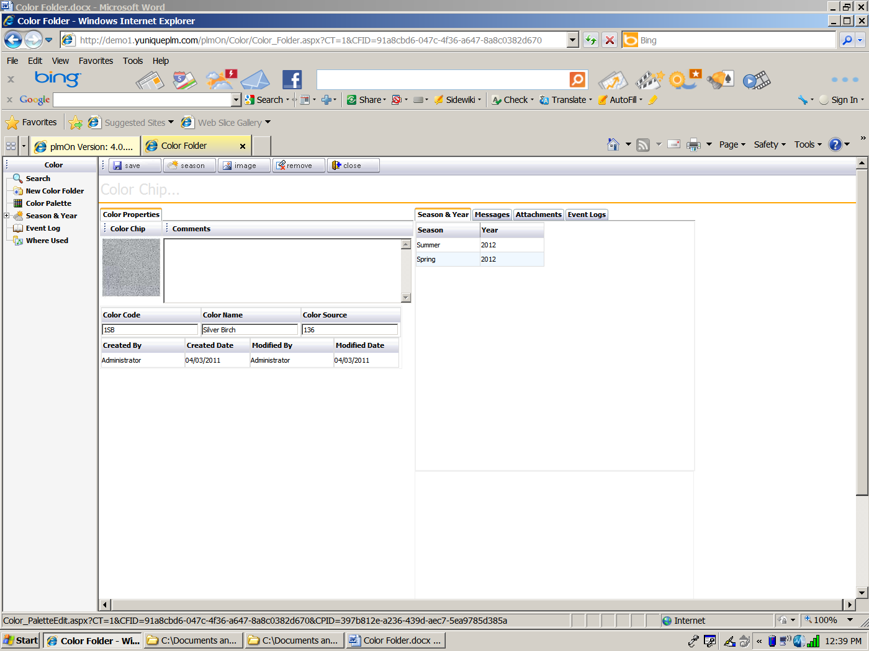

To add or remove season information from this window, click on the season button across the top of the color chip window.



Then from the list of available season/year combination on the left, highlight the desired combinations to add and move them to the right with the arrows in the center. Highlight items on the right and move them to the left to remove unwanted season information.

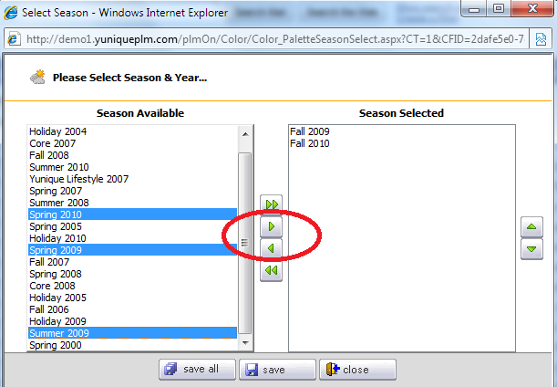

The Messages tab will display any ongoing dialogs about the specific color chip.

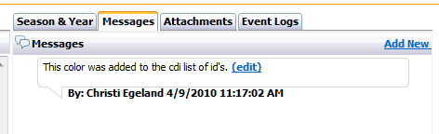

The Attachments tab will store any data files related to the color chip from external sources. For example: excel files, word documents, PDF files, Spectrophotometer readings, etc.

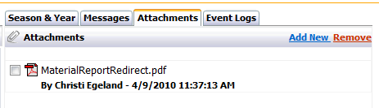

The Events Log tab displays the history of events that have occurred from the time that the color chip is added to the palette.

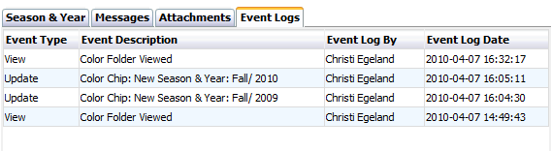

To change the RGB data fields, click on the Set RGB button located across the top of the color chip window.



This will open up a window where a new color can be selected from the display or new values can be added to the specific data entry fields. Once the desired changes have been made, click Save and Close across the bottom of the window.

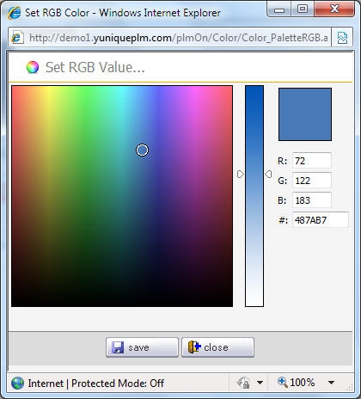

To remove a color chip from a palette, select the Remove button across the top of the window.



If the system is able to delete the color from the palette a dialog box will be presented to verify this action. If styles or materials have been developed using this color information then the user will be prevented from removing the color from the palette.

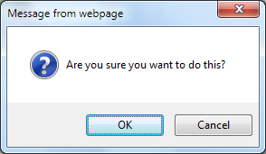

If a color cannot be removed because it has been associated with a style or material, then click on the Where Used label on the left side of the divider bar.

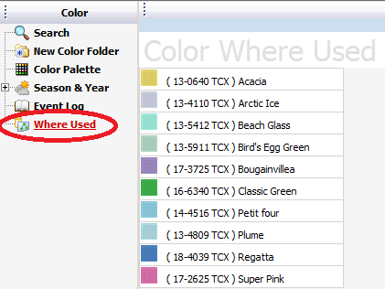

Then click on the individual color chips displayed on the right side of the divider bar. If there are materials associated with the color they will expand below the color chip.

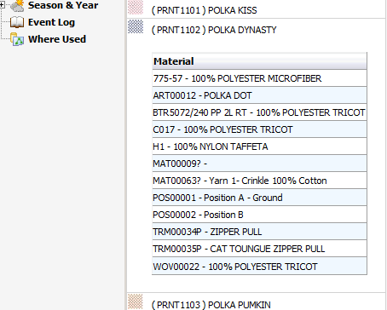

The where used information that is displayed is interactive, and the material folder can be accessed by clicking directly on the listing.

**Sorting Colors in a Palette**

Colors in a palette can be sorted by selecting the sort button across the top of the Color Palette window.



This will display a color list that includes the color code and color name and a sort order number. To sort by color list or color name simply select the preferred option from the drop down list across the top of the screen and click the Sort button to the right. To manually change the sort order, change the sort numbers for each color in the list and click the Save button in the upper right corner.

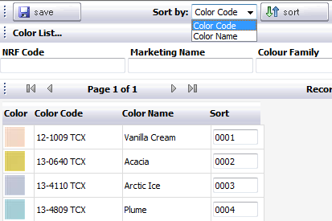

**Uploading Images**

To associate an image with color chip information, click on the Image button across the top of the color chip window.



This will open up the Upload Color window. Browse to a specific color image by clicking on the Browse button in the middle of the window. Once the file path is populated, click on the Save button at the bottom. Then click the Close button to close the window.

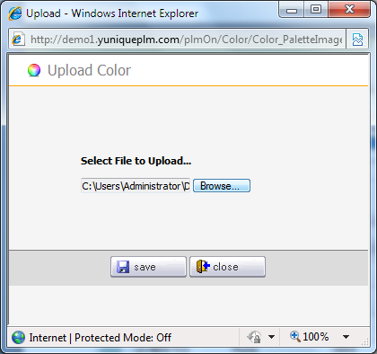

**Deleting a Palette**

To delete a palette, click on the Delete button across the top of the palette window.



If there are no material folders or style folders associated with the color palette information then a dialog will be displayed to verify that the palette should be deleted.

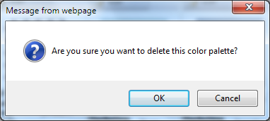

**Color Palette Reports**

To generate a report for a color palette, click on the preview button across the top of the palette.



A list of available reports will be displayed. Once a report has been selected, click the Preview button in the upper left corner to begin generating the report.

NOTE: The first time a report is generated will take longer than other times.

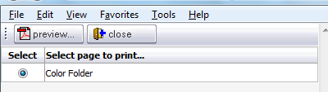

The report will be displayed as a PDF when the system completes the process.

